DHCP and DNS

Topology
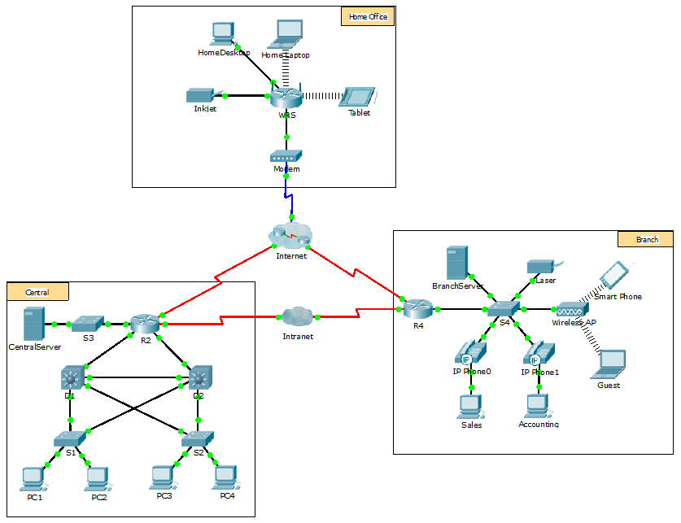
Objectives
Part 1: Configure IPv4 Addressing Using DHCP
Part 2: Configure and Verify DNS Records
Background
In this exercise, you will configure and verify static IP addressing and DHCP addressing. You will then configure a DNS server to map IP addresses to the website names.
Note: Packet Tracer only simulates the process for configuring these services. DHCP and DNS software packages each have their own unique installation and configuration instructions.
- Configure Static IPv4 Addressing
  - Configure the Inkjet printer with static IPv4 addressing.
The home office computers need to know the printer’s IPv4 address to send information to it. The printer, therefore, must use a static (unchanging) IPv4 address.
    - Click Inkjet and click the Config tab, which displays the Global Settings.
    - Statically assign the Gateway address as 192.168.0.1 and the DNS Server address as 64.100.8.8.
    - Click FastEthernet0 and statically assign the IP address as 192.168.0.2 and the Subnet Mask address as 255.255.255.0.
    - Close the Inkjet window.
  - Configure WRS to provide DHCP services.
    - Click WRS and click the GUI tab, and maximize the window.
    - The Basic Setup window displays. Configure the following settings in the Network Setup section:
      - Change the IP Address to 192.168.0.1.
      - Set the Subnet Mask to 255.255.255.0.
      - Enable the DHCP Server.
      - Set the Static DNS 1 address to 64.100.8.8.
      - Scroll to the bottom and click Save.
    - In the Basic Setup display, what is the range of IP Addresses available for DHCP? What is the maximum number of users?
    - Close the WRS window.
  - Request DHCP addressing for the home laptop.
This activity focuses on the home office. The clients that you will configure with DHCP are Home Laptop and Tablet.
    - Click Home Laptop and click the Desktop tab > IP Configuration.
    - Click DHCP and wait until the DHCP request is successful.
    - Home Laptop should now have a full IP configuration. If not, return to Step 2 and verify your configurations on WRS.
    - Which address is allocated? What are the other parameters of the configuration (subnet mask and DNS)
    - Now switch to simulation mode, update the ‘Edit Filters’ so that you catch the DHCP packets only (other protocols packets may appear though), uncheck DHCP in the IP Configuration, wait for few seconds and then click on it again. In the simulation mode, keep clicking on Capture/Forward until the DHCP request is successful and Home Laptop is fully configured.
    - Examine the Simulation Panel: the aim is to establish that the DORA stages have been followed in granting an IP address (DORA stages are: Discover, Offer, Request, and Acknowledgment). You may check multiple packets as few will be dropped (you should focus on traffic between WRS and home laptop.
    - In your quest to establish DORA steps, click on any DHCP packet, select the OSI table -> In Layers, in the description, find out to what purpose the DHCP packet is used. In unsure, please as your lab demonstrator (you may need a good understanding of the DORA steps to complete the exercise further below).
    - Once done, close the any IP Configuration window, close the Home Laptop window and switch back to RealTime mode.
  - Request DHCP addressing for the tablet.
    - Click Tablet and click the Desktop tab > IP Configuration.
    - Click DHCP and wait until the DHCP request is successful.
    - Tablet should now have a full IP configuration. If not, return to Step 2 and verify your configurations on WRS.
  - Test access to websites.
    - Close the IP Configuration window, and then click Web Browser.
    - In the URL box, type 10.10.10.2 (for the CentralServer website) or 64.100.200.1 (for the BranchServer website) and click Go. Both websites should appear.
    - Reopen the web browser. Test the names for those same websites by entering centralserver.pt.pka and branchserver.pt.pka. Click on Fast Forward Time on the yellow bar below the topology to speed the process.

Step 6: Use Ipconfig – release and renew and Request DHCP addressing for the Home Desktop
- Click Home Desktop and click the Desktop tab > IP Configuration, make certain Home Desktop uses DHCP services to get an IP address if it is not configured to do so (in a small / home office environment, one would expect that wireless devices may use DHCP and that wired devices are granted static addresses – routers should be configured to provide IP addresses). Wait for a few seconds till Home Desktop it is granted an IP address.
- Click Home Desktop, click the command prompt and enter ipconfig /release which should end the lease of the current IP address and release it back to the DHCP server (the WRS router in this case).
- Switch to simulation mode, update the simulation panel by clicking the Edit Filters and appropriately select the protocol(s) packets you may need to examine. In Home Desktop command prompt enter ipconfig /renew to obtain a new lease. Click on Capture / Forward several times until a new IP is granted (you may make sur you have a new address by examining the display on Home Desktop IP Configuration window or by entering ipconfig in the command prompt when allowed to do so).
- What is the source and destination IP addresses in DHCP Discover (referring to the DORA steps) packet?
- In the DHCP Offer packet, what is the IP address offered by WRS to Home Desktop ?( Hint: you may need to examine layer 7 in the packet)
What are the destination MAC addresses used in the Discovery and Acknowledgement DHCP packets?
- Configure Records on the DNS Server
  - Configure famous.dns.pka with records for CentralServer and BranchServer.
Typically, DNS records are registered with companies, but for the purposes of this activity you control the famous.dns.pka server on the Internet.
    - Click the Internet cloud. A new network displays.
    - Click famous.dns.pka and click the Services tab > DNS.
    - Add the following resource records:
Resource Record Name | Address
centralserver.pt.pka | 10.10.10.2
branchserver.pt.pka | 64.100.200.1
    - Close the famous.dns.pka window.
    - Click Back to exit the Internet cloud.
  - Verify the ability of client computers to use DNS.
Now that you have configured DNS records, Home Laptop and Tablet should be able to access the websites by using the names instead of the IP addresses. First, check that the DNS client is working properly and then verify access to the website.
    - Click Home Laptop or Tablet.
    - If the web browser is open, close it and select Command Prompt.
Verify the IPv4 addressing by entering the command ipconfig /all. You should see the IP address for the DNS server.
    - Ping the DNS server at 64.100.8.8 to verify connectivity.
Note: The first two or three pings may fail as Packet Tracer simulates all the various processes that must occur for successful connectivity to a remote resource.
Test the functionality of the DNS server by entering the commands nslookup centralserver.pt.pka and nslookup branchserver.pt.pka. You should get a name resolution showing the IP address for each.
    - Switch to simulation mode and select the appropriate event / protocol in the simulation panel (Edit Filters). Retest the functionality of the server by entering the command nslookup edgeserver.pt.pka and then click Capture / Forward. Once received by Home Laptop, what does the DNS response packet tell us about the IP address for the queried domain (is this case edgeerver.pt.pka)
    - What is the DNS port number used for the service?
    - Close the Command Prompt window and click Web Browser. Verify that Home Laptop or Tablet can now access the web pages for CentralServer and BranchServer.

